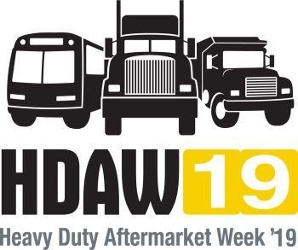

**DISTRIBUTOR**

**HDAW One-on-One Meetings**

**January 30-31, 2019**

**Mirage Hotel & Casino**

**Las Vegas, Nevada**

DISTRIBUTOR ONE-ON-ONE SIGN UP FORM

Yes, our company will have ❑1 ❑ 2 ❑ 3 sets/teams for the One-on-One of meetings.

For 2019 all distributors will make their selections for meetings with exhibiting suppliers online at [www.hdaw.org](http://www.hdaw.org) (further instructions to come) and for those companies having more than one team, make sure you assign a different team member to make selections for each team using their registration ID#. Make sure each team captain does NOT select the same suppliers. List your team captains below

Team 1: __________________________ Team 2: _______________________ Team 3: ________________________

**NOTE: If you have more than 1 representative attending the event, multiple teams are highly recommended**.

**With the volume of meetings being scheduled we cannot waste any time periods. If you cannot attend a scheduled meeting, please contact the supplier ASAP so they can fill that timeslot with another customer.**

**Be courteous!**

**Once you are in the One-on-One selection program you will have the opportunity to block out the times you DO NOT want meetings scheduled.**

**\*\*\*\*DEADLINE FOR REGISTERING FOR THE ONE-ON-ONE MEETINGS IS FRIDAY, NOVEMBER 9TH, 2018**

**IF YOU HAVE ANY QUESTIONS ABOUT THE ONE-ON-ONE PROGRAM SIGN UP, CONTACT MARGO REYES AT**

**904-737-2900 or EMAIL** [**margo@cvsn.org**](mailto:margo@cvsn.org)

**Company Name: __________________________________________________________________**

**On Site Contact(s): ________________________________________________________________**

**On Site Contact E-Mail(s):___________________________________________________________**

**Phone: ________________________________ Fax: _____________________________________**

**Address: ______________________________________ZIP/Postal Code: ____________________**

Complete this form and **Email** to[margo@cvsn.org](mailto:margo@cvsn.org) or **Fax** to **904-636-9881**

If you have any questions, call 904-737-2900.

**ALL PARTICIPATING DISTRIBUTORS MUST RETURN THE SIGN UP FORM NO LATER THAN**

**FRIDAY, NOVEMBER 9TH, 2018**